
Brainstorming

This is a technique that helps generate ideas for an essay or story. It is the first step to successful writing.

Look at the picture below and answer the 5 W questions.

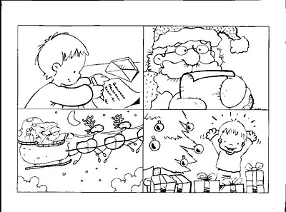

Who:
Answer questions about the characters:
- Name
- Age
- School
- Class
- Siblings
What:
Answer questions about the action taking place:
- Is the boy writing?
- Presents does he want?
- Why does he give to Santa?
Where:
Answer questions about the setting:
- Does the boy live?
- Does he send the letter?
When:
Answer questions about the timing of events:
- Does the boy write the letter?
- Does he get the presents?
Why:
Answer questions about what is learnt:
- Was this experience so special?
- Was the boy so happy?

